Download and install Arduino IDE. The one I am using is Arduino 2.0.4.

<https://www.arduino.cc/en/software>

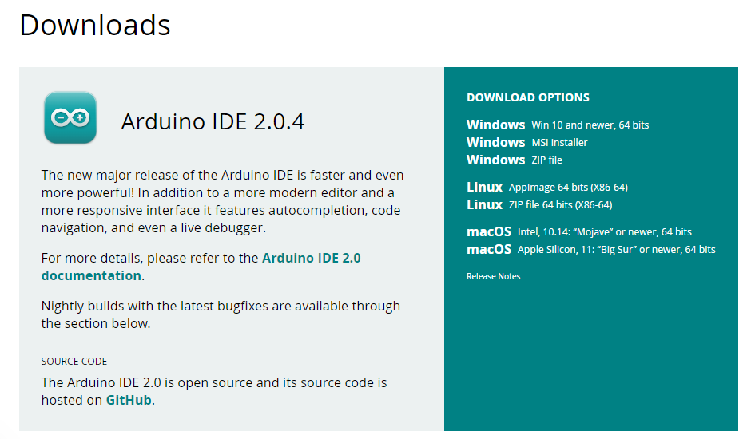

Go to Sketch >> Include Library >> Manage Libraries

Search for **LiquidCrystal_I2C** and install the latest version.

Now search for **ArduinoJson** and install the latest version.

Make the connections as shown in Schematics.

Upload the code Arduino MEGA

Errors will print on Serial monitor, make sure baudrate of serial monitor is set to 115200.

**Pull Down:**

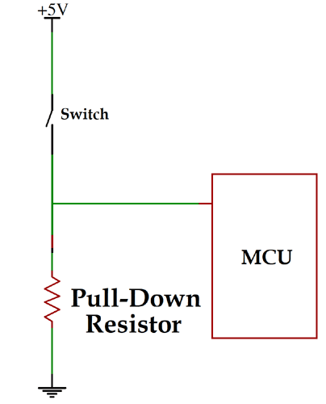

Connector

Pull down resistor makes sures that the default state of pin is LOW.

Pin will only get HIGH if Arduino or external source make it HIGH.